Coffee Sales Performance Analysis Report
Prepared by: Emmanuel Ayodele
Date: November 3, 2025
Tool Used: Microsoft Excel (Analysis and Dashboard)

1. Executive Summary
This report provides an analysis of the coffee shop's sales performance using transaction data to identify key revenue drivers, peak operational periods, and areas for strategic improvement.
The analysis, covering a dataset of 47,782 transactions, reveals a Total Revenue of $230,057.25 with significant growth observed in the latter months. Key findings highlight that Coffee is the dominant product category, while operational efficiency can be optimized by staffing to align with clear peak transaction times occurring during the early morning hours (7 AM - 11 AM).

2. Objectives
The primary objectives of this analysis were to:
- Determine the distribution of sales and revenue across different product categories.
- Identify peak sales periods by hour of the day and day of the week to inform staffing and inventory.
- Analyze revenue trends over time to understand business growth.
- Provide data-driven recommendations to enhance sales and operational efficiency.

3. Key Findings & Statistical Insights
Metric | Value | Insight
Total Transactions | 47,782 | High volume of customer activity, suggesting a strong customer base.
Total Revenue | $230,057.25 | Strong overall sales performance for the analyzed period.
Top Product Category | Coffee | Accounts for the highest total sales, confirming it as the core business driver.
Lowest Product Category | Coffee Beans | This low sales volume suggests an opportunity for promotional efforts or a review of product placement/pricing.
Peak Sales Hour | 10 AM | The hours between 7 AM and 11 AM account for the highest transaction volumes, indicating the morning rush is critical.
Peak Sales Day | Monday | Mondays and the beginning of the week generally see the highest revenue, indicating strong demand immediately following the weekend.
Revenue Trend | Growing | The Revenue Per Month visualization shows sales are consistently increasing, with a notable jump from February onwards.

4. Detailed Analysis and Visualizations
A. Product Category Performance
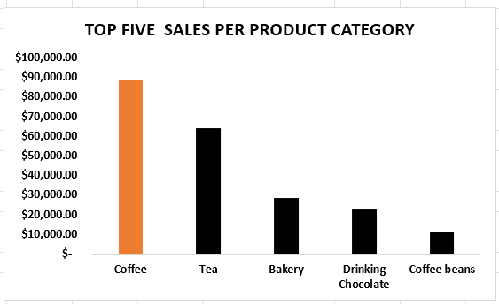
The analysis of Total Sales per Product Category confirms the following hierarchy in revenue generation:
- Coffee
- Tea
- Bakery
- Drinking Chocolate
- Coffee Beans
The disparity between Coffee and Coffee Beans is significant, suggesting a need to investigate the pricing, marketing, and display of coffee beans to capitalize on the success of brewed coffee.

B. Operational Peak Times
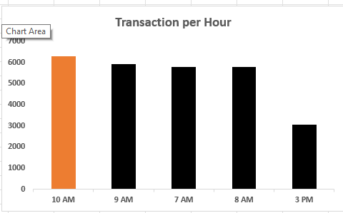
The Transaction per Hour chart clearly shows two major peaks:
- A strong, sustained morning peak (7 AM - 11 AM), with 10 AM being the single busiest hour.
- A secondary afternoon peak around 3 PM.
The majority of the day's sales activity occurs within the first 12 hours of the business day.

C. Weekly & Monthly Performance
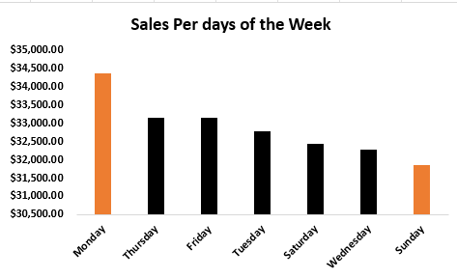
- Sales per Day of the Week indicates Monday leads the week, followed closely by Tuesday through Friday. This suggests weekday commuter traffic or routine morning customers are the primary revenue source.
- Revenue per Month demonstrates a positive trend, with sales growing consistently across the analyzed months. This upward trajectory is a positive indicator of market acceptance and successful business scaling.

5. Recommendations
Based on the statistical insights and analysis, the following actions are recommended for optimizing revenue and operations:
- Optimize Staffing: Schedule the majority of staff resources to cover the 7 AM to 11 AM window, as this accounts for the highest transaction volume. Employ fewer staff in the slower early and late hours to reduce labor costs.
- Promote Low-Volume Products: Implement targeted marketing and in-store promotions (e.g., cross-selling deals with Coffee purchases) specifically for Coffee Beans and Drinking Chocolate to increase their contribution to total revenue.
- Investigate Monthly Fluctuation: The data shows a sudden drop in revenue from January to February. A deeper dive is recommended to identify the specific causal factors (e.g., a holiday, bad weather, or a operational issue) to prevent this from repeating in future years.
- Customer Loyalty Program: Given the high transaction count (47,782), introducing a loyalty or subscription program could solidify the high frequency of repeat customer visits observed during the peak hours.

